Vishal Pokuri

22BKT0102

MongoDB final Project

Title: Kanban Task Board

Description: A full stack draggable and Droppable Kanban Board model task manager. Create, Drag, reorder, remove whatever you want.

Backend

Implemented Backend with Node.js (Express.js)

**Authentication Routes**

- POST /api/auth/login - User login with email and password

- POST /api/auth/register - User registration with name, email, and password

**Column Routes**

- GET /api/columns/{userId} - Fetch all columns and their tasks for a specific user

- POST /api/columns - Create a new column (requires title and userId)

- PUT /api/columns/{columnId} - Update column title

- DELETE /api/columns/{columnId} - Delete a column (requires userId in body)

**Task Routes**

- POST /api/tasks - Create a new task (requires columnId and content)

- PUT /api/tasks/{taskId} - Update task content

- DELETE /api/tasks/{taskId} - Delete a task (requires columnId in body)

**Fetch User Data:**

- Retrieves all columns belonging to a user with their nested tasks

- Tasks are flattened into a separate array with columnId references

**Column Management:**

- Create: Generates default title "Column X"

- Update: Changes column title

- Delete: Removes column and all associated tasks

**Task Management:**

- Create: Generates default content "Task X"

- Update: Changes task content

- Delete: Removes individual task from column

MongoDB Models used

Column

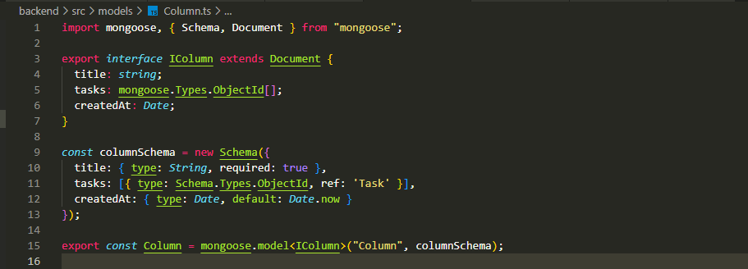

Task

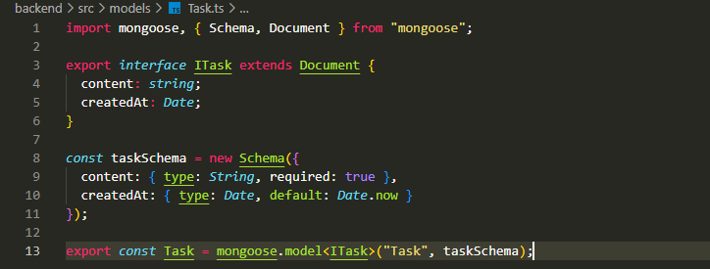

User

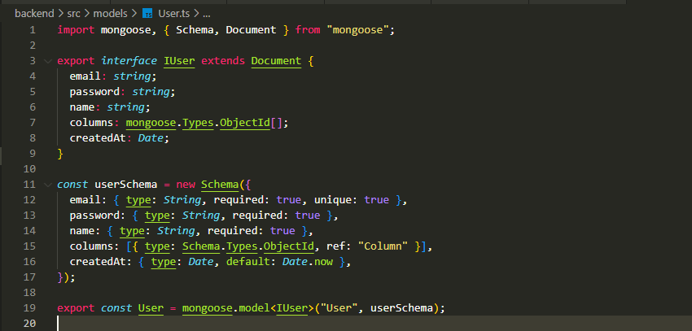

**Implementations**

Registration Page: **POST /api/auth/register**

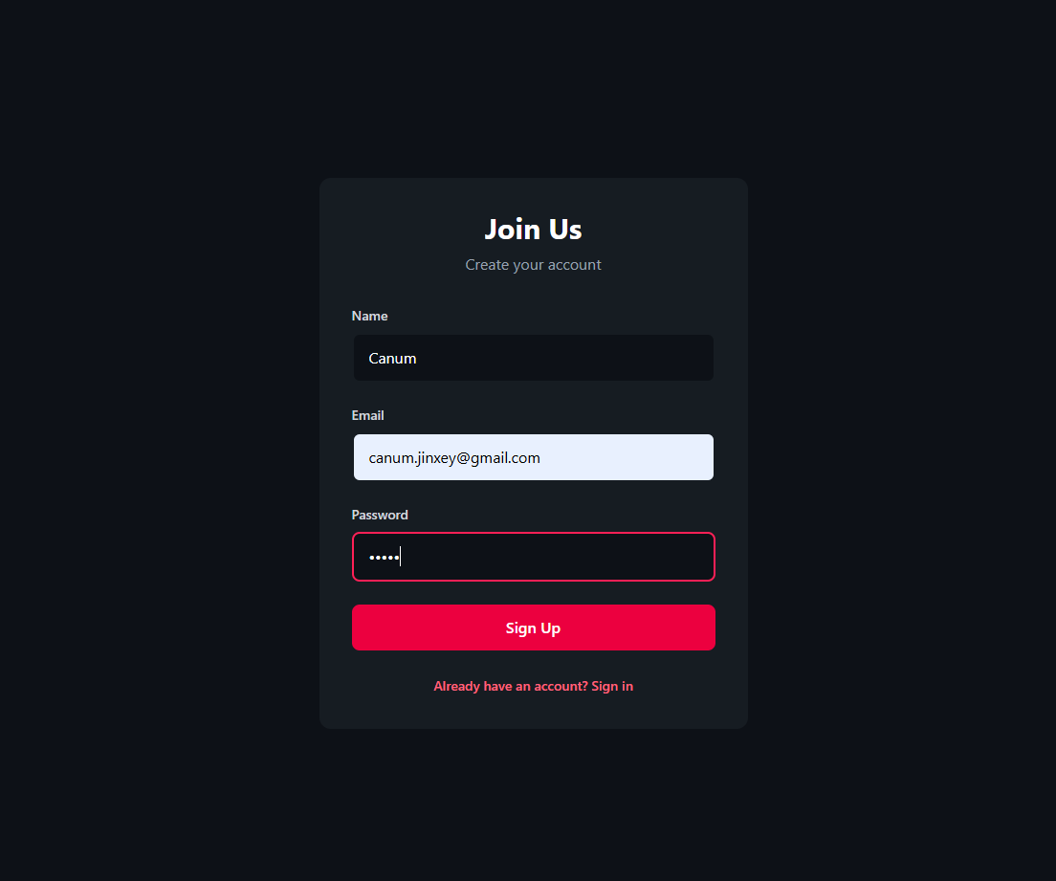

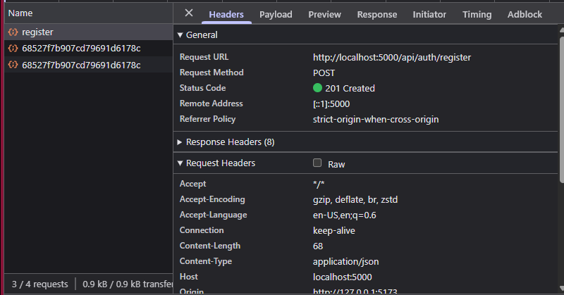

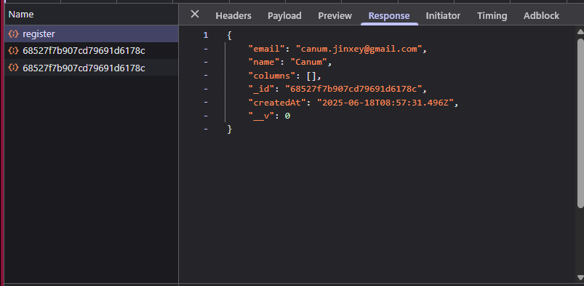

Login Page - **POST /api/auth/login**

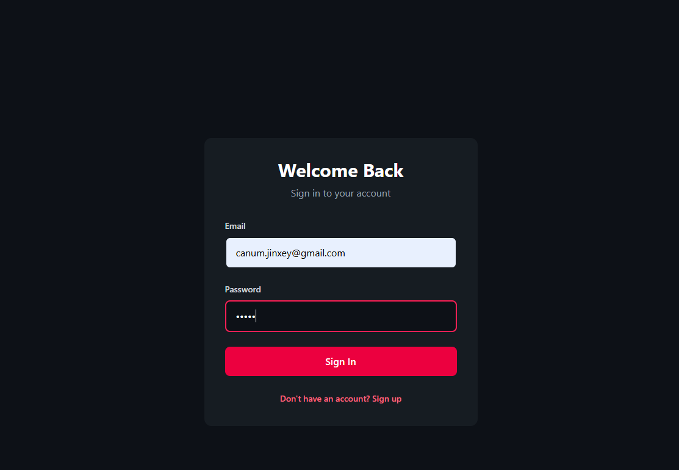

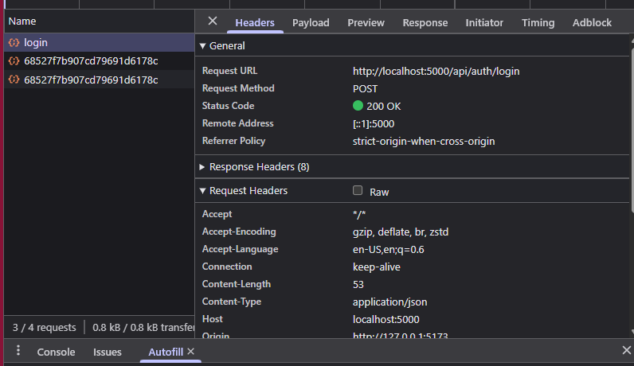

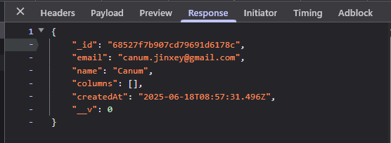

Column Creation – **POST /api/columns**

From 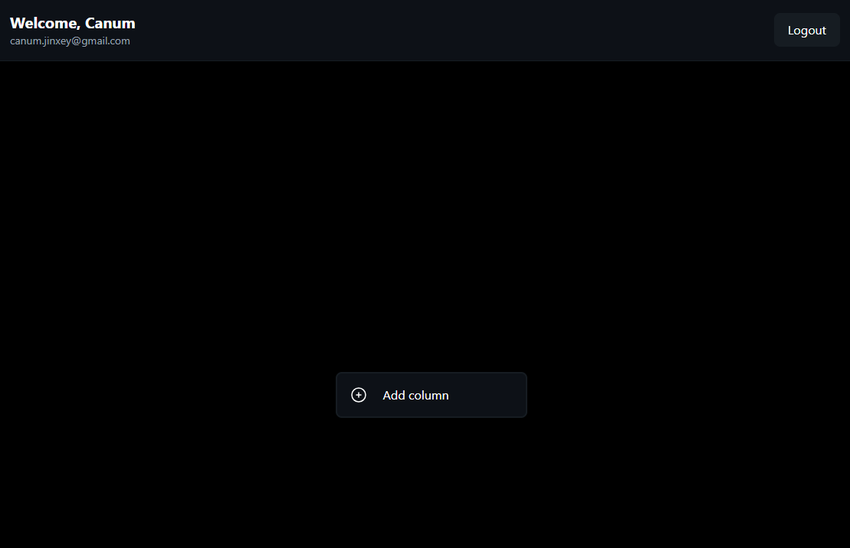

To

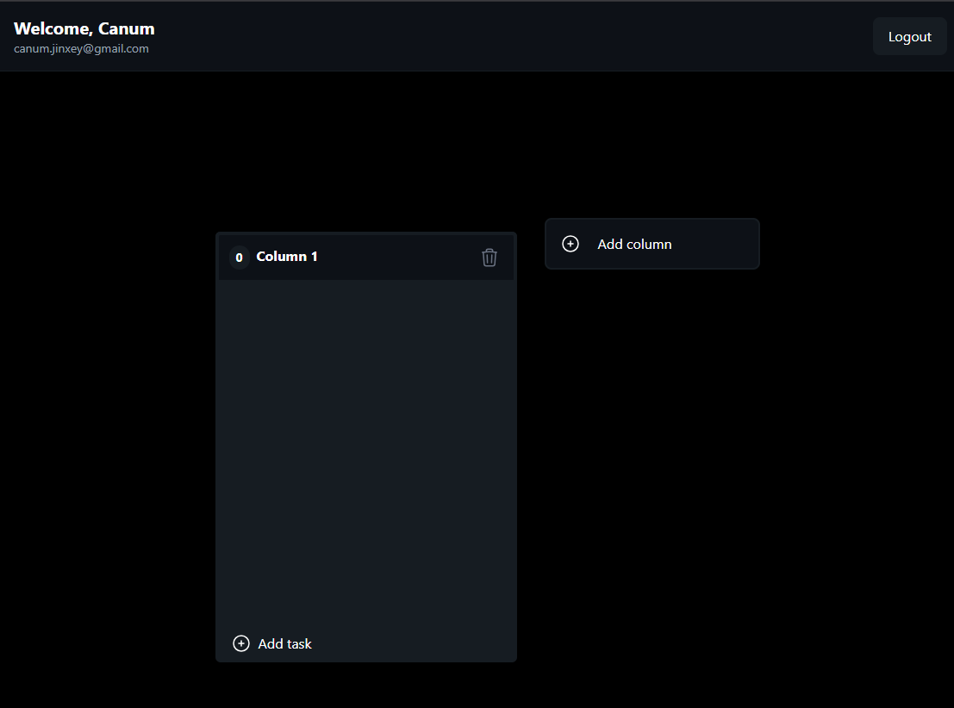

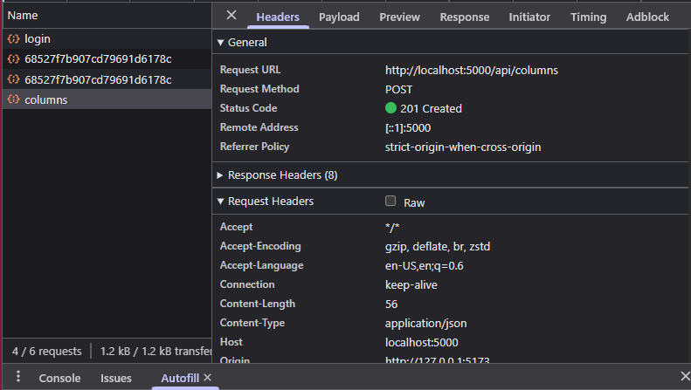

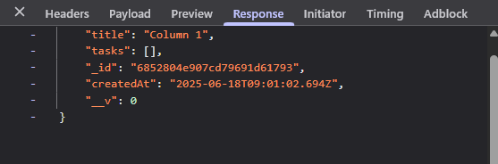

Fetching Columns at the time of Login: - GET /api/columns/{userId}

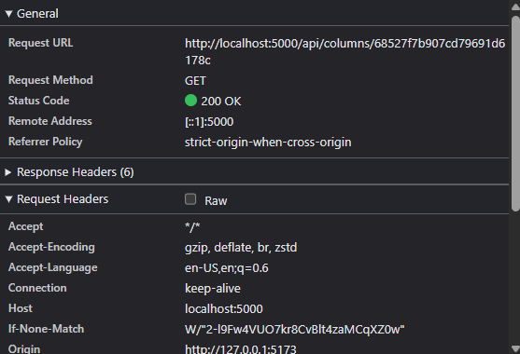

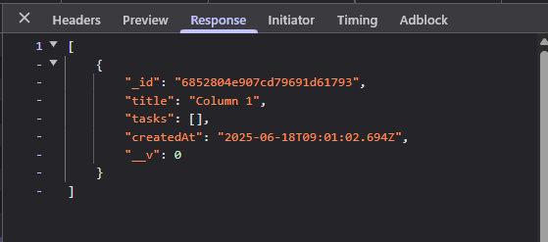

Updating the column title: **PUT /api/columns/{columnId}**

From

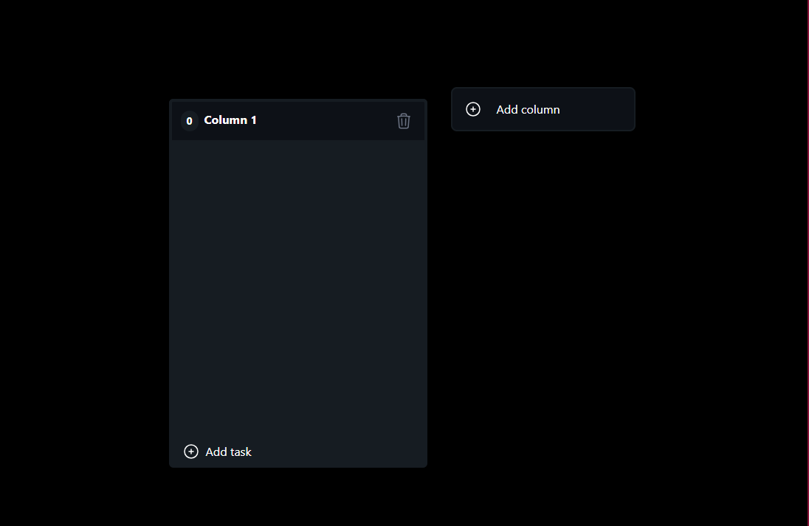

To

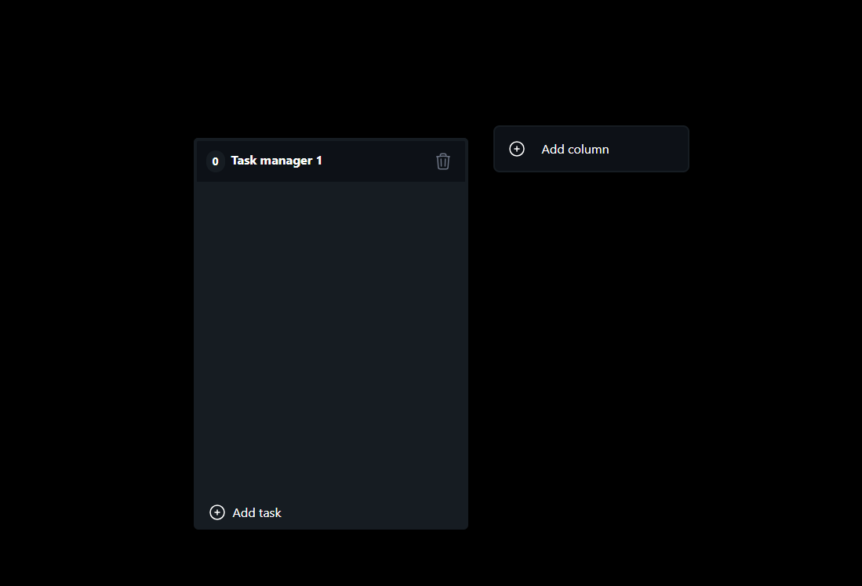

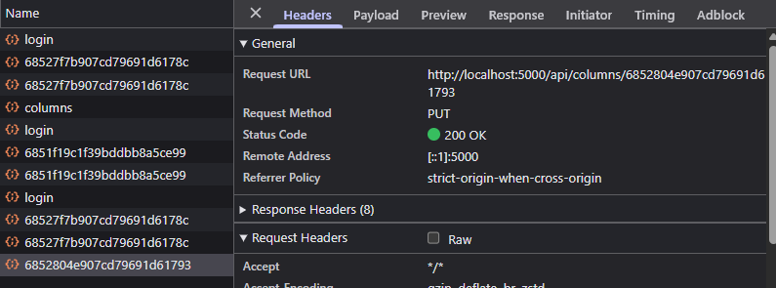

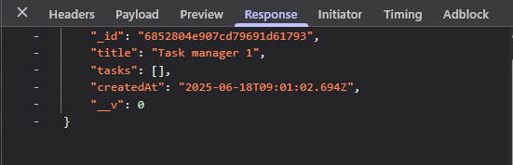

Deleting a column and its tasks - **DELETE /api/columns/{columnId}**

From

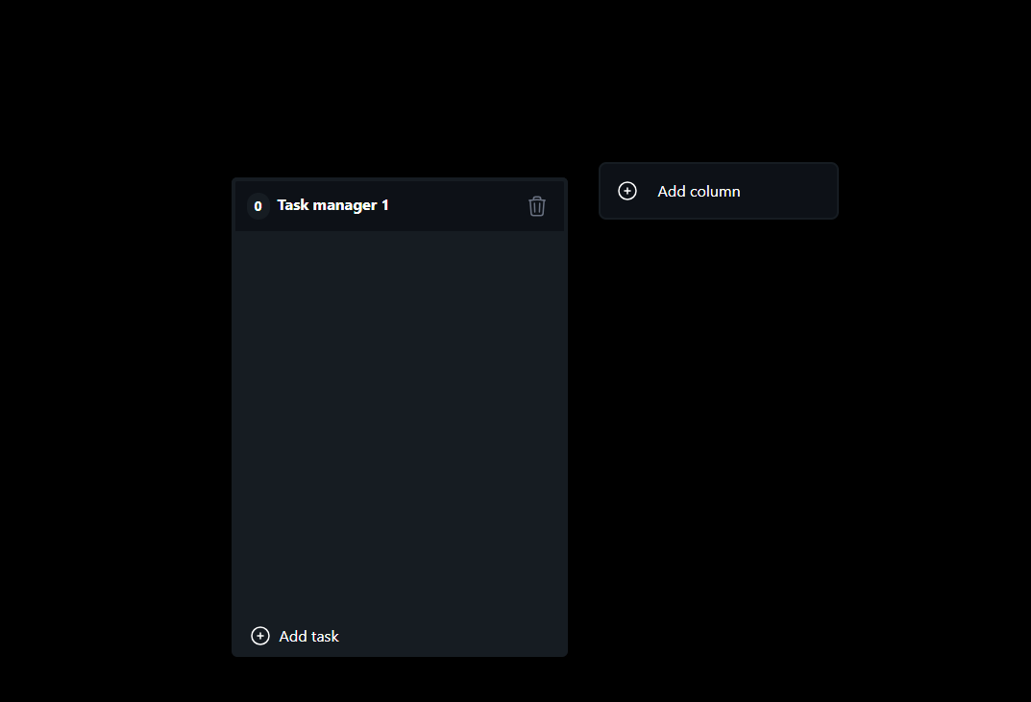

To

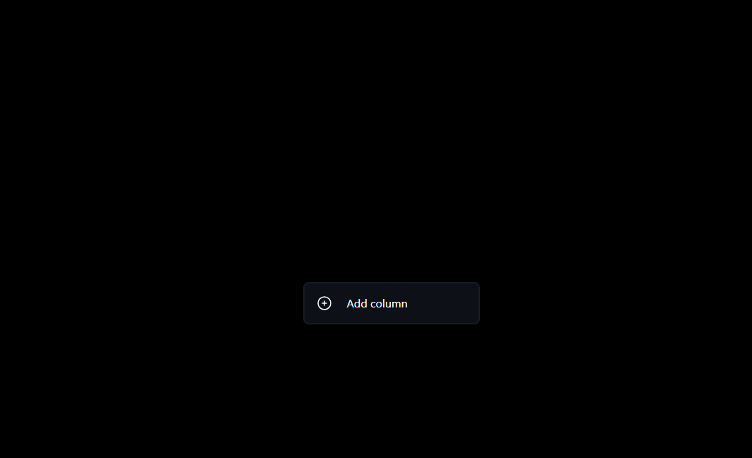

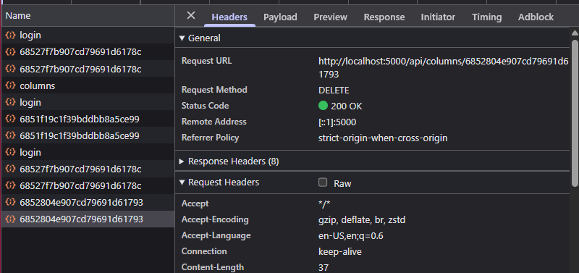

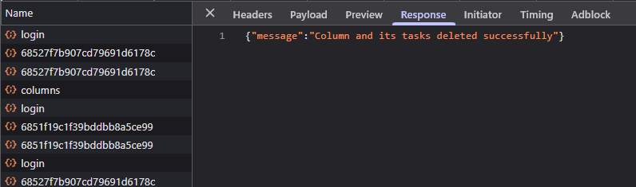

Creating a task in a Column: **POST /api/tasks**

From

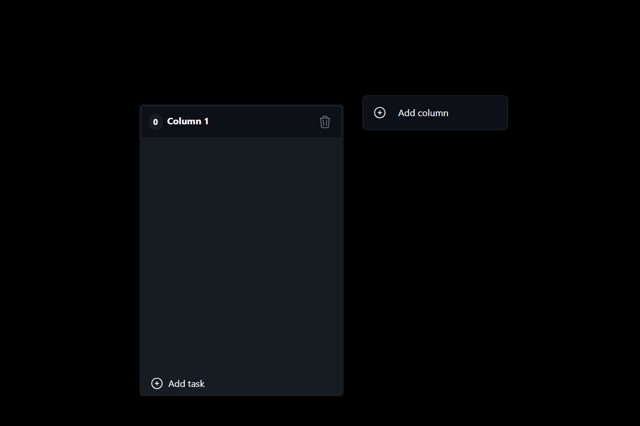

To

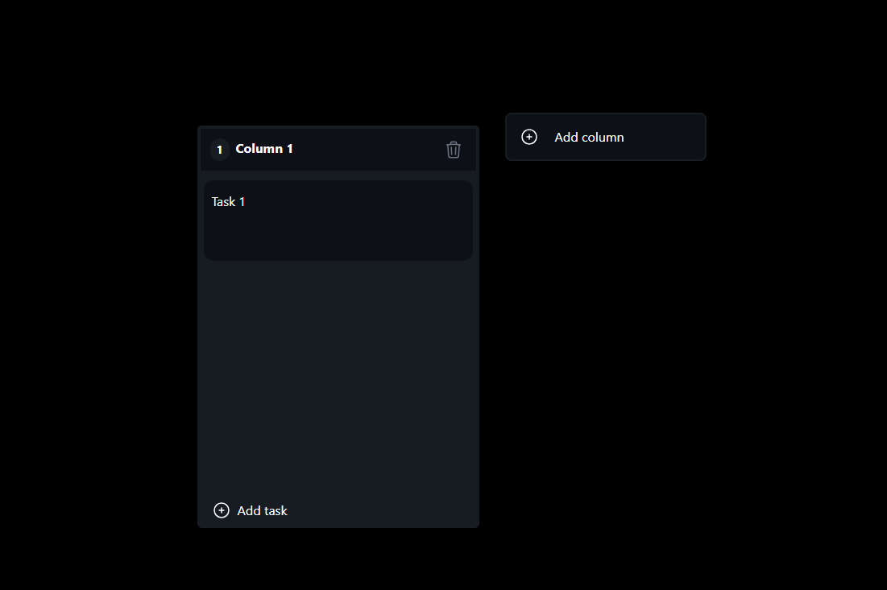

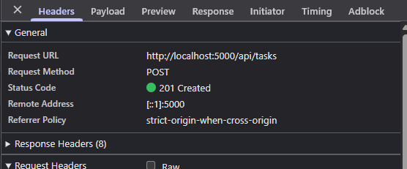

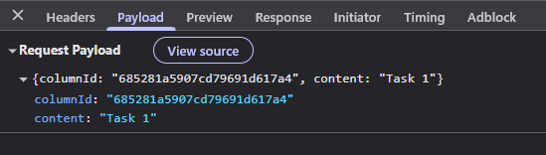

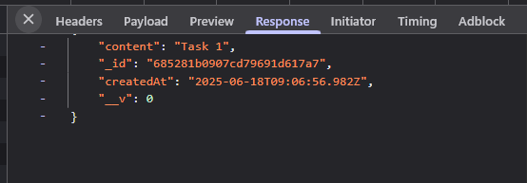

Update Task content – **PUT /api/tasks/{taskId}**

From



To

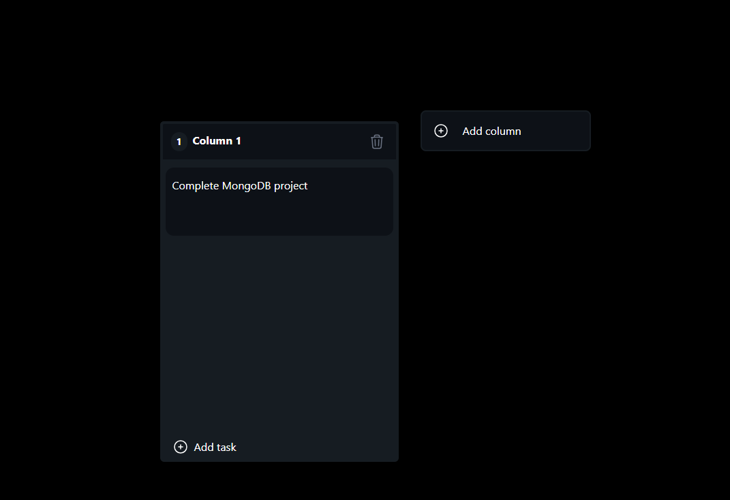

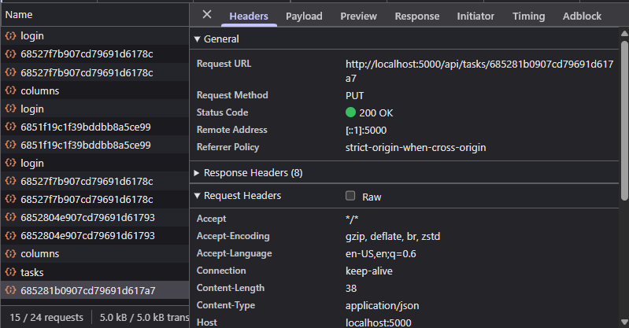

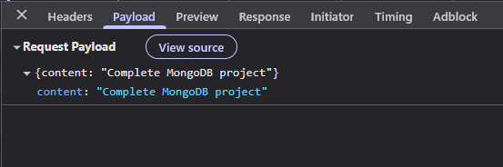

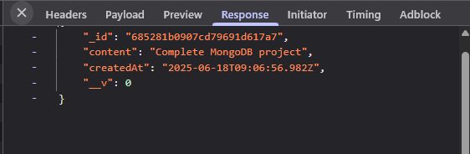

Delete a task - **DELETE /api/tasks/{taskId}**

From



To : clicked on delete button

